Volunteer Emergency Worker Meeting - Notes

October 17, 2018

CERT organization:
- Shoreline is hosting a CERT class. Role players are needed for CERT final Sunday October 21. Contact Laurell Sprague MoulageMayhem1@gmail.com [Discussion in the works of role playing as a possible means of earning credentials.]
- For anyone interested in being a moulage artist…..a Beginner Moulage class on Saturday, October 27, in Tulalip. If you are interested, MoulageMayhem1@gmail.com
- LAST CALL - Volunteers needed for our CERT steering committee. If you are interested in playing a key role in developing what types of training and drills our CERTs do in the future, this may be for you. We will be meeting at least once before the end of the year to develop plans for 2019 Interested? If so, we are looking for 2-3 more wanting to guide our group. Contact Carl clunak@northshorefire.com.

Emergency Response Zones: NEMCo neighborhoods, Kenmore and Lake Forest Park are divided into 12 different subzones. The goal of dividing up the area is to make it a little easier to integrate CERT teams, map your neighborhood groups and HAM radio operators. The long term goal is to identify HAM radio operators in each zone who can convey information (damage assessments) to Emergency Operations Center. The zones also make it possible to facilitate communication from the EOC to citizens.

Website: www.NorthshoreRACES.com (all things amateur radio) website is up. www.NorthshoreCERT.com is the primary page for all things emergency, volunteer opportunities, training, etc. A very special thank you to Dan Agun, his son Michael, Scott Green and Gail Siani for their work on this project.

Vests/Hats: Become an official volunteer and receive an official CERT vest, e.g., take a CERT class, have a background check and become credentialed. (Note that the standard safety vest issued with the CERT graduation backpack is okay and works fine.) Hats— the group had lots to say about HATs and other logo gear. We may need to have a NEMCo gear subcommittee to decide on future items. Stay tuned.

Hurricanes in Carolina and Florida panhandle. Devastation due to wind, tidal surge, and lowland flooding. Florence: Emergency managers were pleased with preparation due to advance notice. Alert system reached a lot of people and evacuees got out of the way. Michael: Response was not the same due to changing description of hurricane’s size along with those who did not evacuate. Note: 1) Be aware that technology or resources may or may not work or be available due to status of infrastructure (towers that are down or supply of gas). 2) Check with insurance provider and be aware of nuances in your insurance policy regarding natural disasters, e.g., structural versus contents of houses.

Presidential Alert operates much like an Amber Alert or Northshore alerts but are nationwide. Response was mixed as many people did not get the alert while others on the same cell provider got it multiple times. The question was raised as to what kind of disasters is this national level alert is in response to, with no clear answer.

Communication Drill on September 29 was the State of WA. 5th Saturday drill. NEMCo amateur radio folks received an Alert Northshore text and email, checked into the resource NET and then were assigned a location to go to. The exercise was a success for NEMCo. We accomplished many of our goals and found some areas to improve on. A full report will be out soon.

WARN (Water Wastewater Agency Response Network) held a functional exercise in which NEMCo participated. It included Department of Ecology, WA State Department of Health Drinking Water, Seattle Public Utilities, King County, Washington Association of Sewer & Water Districts and many more). The premise of the exercise was a Mt. St. Helens eruption with the ash being blown North. The exercise successfully tested the WARN Mutual Aid and assistance agreement between water and wastewater utilities whereby resources can be shared.

Upcoming Events

October 18, 2018 Great Shakeout Drill (10/18 at 10:18am). Drop, Cover, Hold.

October 20, 2018; Food4Kids 5K fundraiser for food. 9:00 a.m. in Shoreline at 175th & Interurban Trail. https://tinyurl.com/ybjd6yoy

NEMCo’s next CERT begins Monday nights January 7, 2019. Registration will start after Thanksgiving. Note: Teen CERT classes in the works.

Change in meeting date: Our November meeting will be moved to the week after Thanksgiving. The new date will be 11/28. The December 19, meeting will stay on the 19th. The December meeting is a potluck, Emergency Preparedness Jeopardy, prizes, etc.

Training
FRS/GMRS radios: FRS and GMRS are two overlapping radio services defined by the FCC.
FRS (Family Radio Service) is free, and no license is required. It offers a shorter range of operation due to low power and antenna restrictions.
GMRS (General Mobile Radio Service) covers a much farther range through higher power and the options of external antennas and repeater operation. However, it requires a license. The license is $65 for 10 years with a simple, online application. There is no exam. The license covers your entire “family.” The word family here is defined broadly. For example, it extends to step-grandchildren and in-laws.
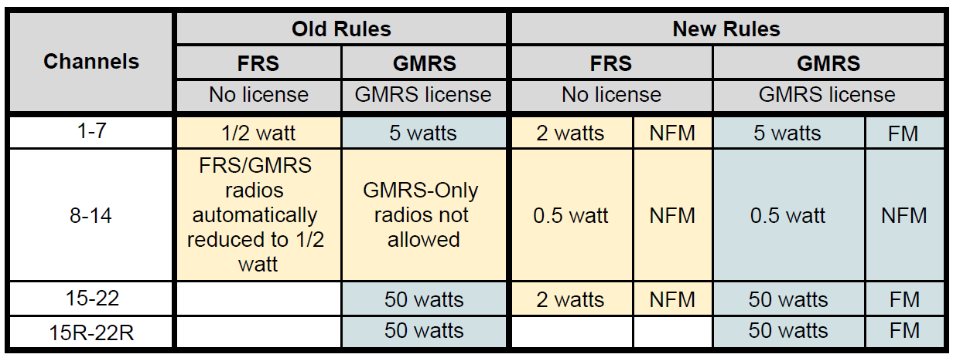
Both services have access to all 22 channels, but there are differences in permitted transmission power and FM deviation between services. The channels are illustrated in the table above, where FM refers to a deviation of 5kHz and NFM means a deviation 2.5kHz. What FM deviation means to you is, GMRS radios are going to sound about twice as loud and clear as FRS radios operating at the same power level on channels 15-22 and, consequently, GMRS radios will have a better signal-to-noise ratio.
There is also a label in the left-most column of the table above that says 15R-22R. This introduces another difference between the FRS and GMRS services. GMRS can operate on repeater receive frequencies, but FRS cannot. Repeaters use two frequencies, one on which they listen (receive) and one on which they talk (transmit). FRS can only use the frequency on which the repeaters talk. GMRS can use both and can talk to the repeater on the channel on which the repeater is listening. What this means is that a GMRS operator will hear the FRS operator (without benefit of the repeater) and the FRS operator will hear the GMRS operator through the repeater. Of course, if no repeater is available, the GMRS operator can change channel and now the FRS and GMRS operators can communicate on the channel reserved for repeater transmission. Some places, you will see references to “all 30 channels” and this refers to all of the channels in Figure 2, including the 15R-22R repeater “listening channels”.
There are other regulation differences between FRS and GMRS. FRS radios must use only permanently attached antennas, although there are table-top FRS “base station” radios that have whip antennas. This limitation intentionally restricts the range of communications, allowing greatest use of the available channels by the community. GMRS does not have this restriction and can have detachable antennas that can be placed on a car top or roof.
Buying Guide (Not an official endorsement)!!!!
The choice of a FRS or GMRS radio can be bewildering. Manufacturers do not help the situation. Here are a few tips to help you get started.
- Stick with Motorola or Midland – These are reputable manufacturers with extensive selections, and the CERT programs has pretty much standardized on them. If you have another make of radio, be advised that some manufacturers assign different channel numbers to same radio channel. For example, Midland channel 1 is ICOM channel 9.
- Don’t pay much attention to claims about transmission distance (packaging often indicates 30+ mile coverage) – These claims are for perfect conditions, such as over water and from mountain peak to mountain (line-of-sight). We in the Pacific Northwest are rarely so lucky. For the highest power GMRS radio, plan on a range of between ½ mile to 2 miles at best in an urban environment. Remember, transmission power is not as important as using a good location and proper operating technique.
- Plan on paying as much if not more for necessary accessories as for the radio. Most radios come with a charging station, a single rechargeable battery, and an earphone. Here are some other accessories you will want to add. Count on paying about $15-$20 for each one of these.
  - An acoustic earphone/microphone – The earpieces that come with the radios are typically not very good. You need a good earphone/microphone to operate hands-free in search and rescue situations.
  - Extra rechargeable battery and possibly an additional charger
  - An adapter for AA batteries if the radio does not accommodate AA batteries
  - A “battery eliminator,” which permits you to run your radio off of a cigarette lighter or automobile battery
  - If you have a GMRS radio, you will need an adapter from your radios antenna outlet to the standard OS-239 UHF connector found on most antennas.
Note that you can purchase all of these through many online stores, which gives you many opportunities to do comparison-shopping.
Much more on FRS/GMRS to come!!!!
Frequency list:
FRS1 462.5625
FRS2 462.5875
FRS3 462.6125
FRS4 462.6375
FRS5 462.6625
FRS6 462.6875
FRS7 462.7125
FRS8 467.5625
FRS9 767.5875
FRS10 467.6125
FRS11 467.6375
FRS12 467.6625
FRS13 467.6875
FRS14 467.7125
GMRS1 462.55
GMRS2 462.575
GMRS3 462.6
GMRS4 462.625
GMRS5 462.65
GMRS6 462.675
GMRS7 462.7
GMRS8 462.725

Next meetings: November 28 and December 19, 2018

